***1. Find all the topics and tasks which are thought in the month of October.***

db.topics.aggregate([

{$match: {month: "october", task: {$ne: "no task"}}},

{

$project: {task: 1, topic: 1},

},

]);

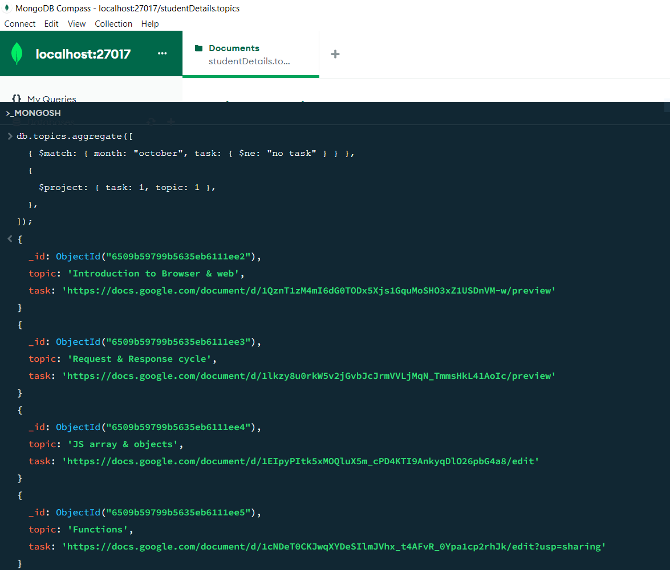

***2.Find all the company drives which appeared between 15 oct-2020 and 31-oct-2020.***

db.company_drives.aggregate([

{$match:{

Date:{$gte:"15-cot-2020",$lte:"31-oct-2020"}

}

},

{

$project:

{

company_name:1,

Date:1

}

}

])

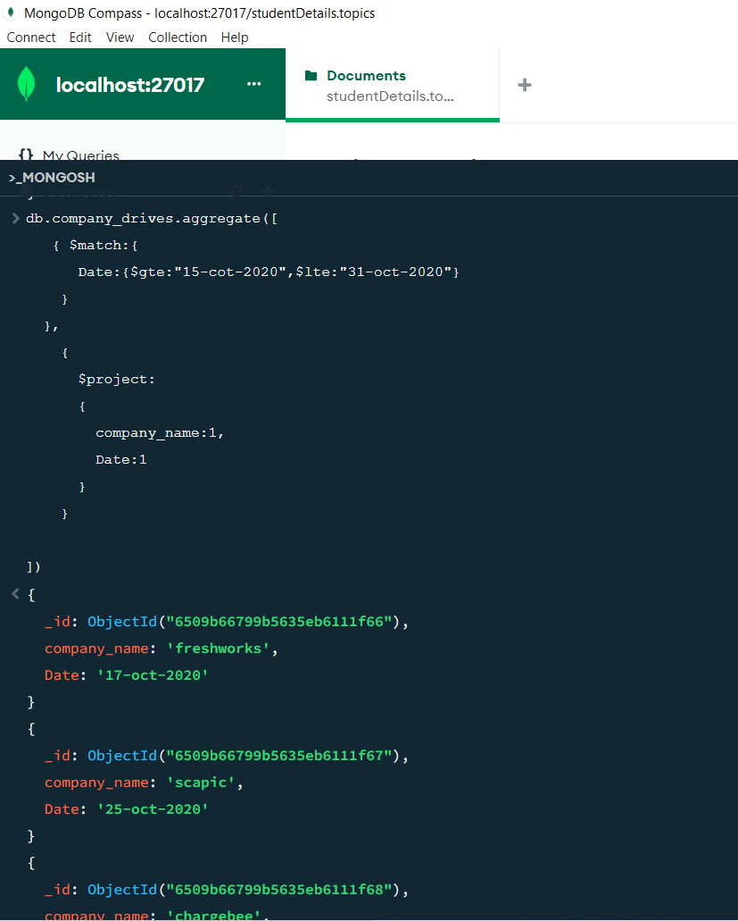

***3.Find all the company drives and students who are appeared for the placement.***

db.company_drives.aggregate([

{ $project: { company_name: 1, students_appeared: 1 } },

]);

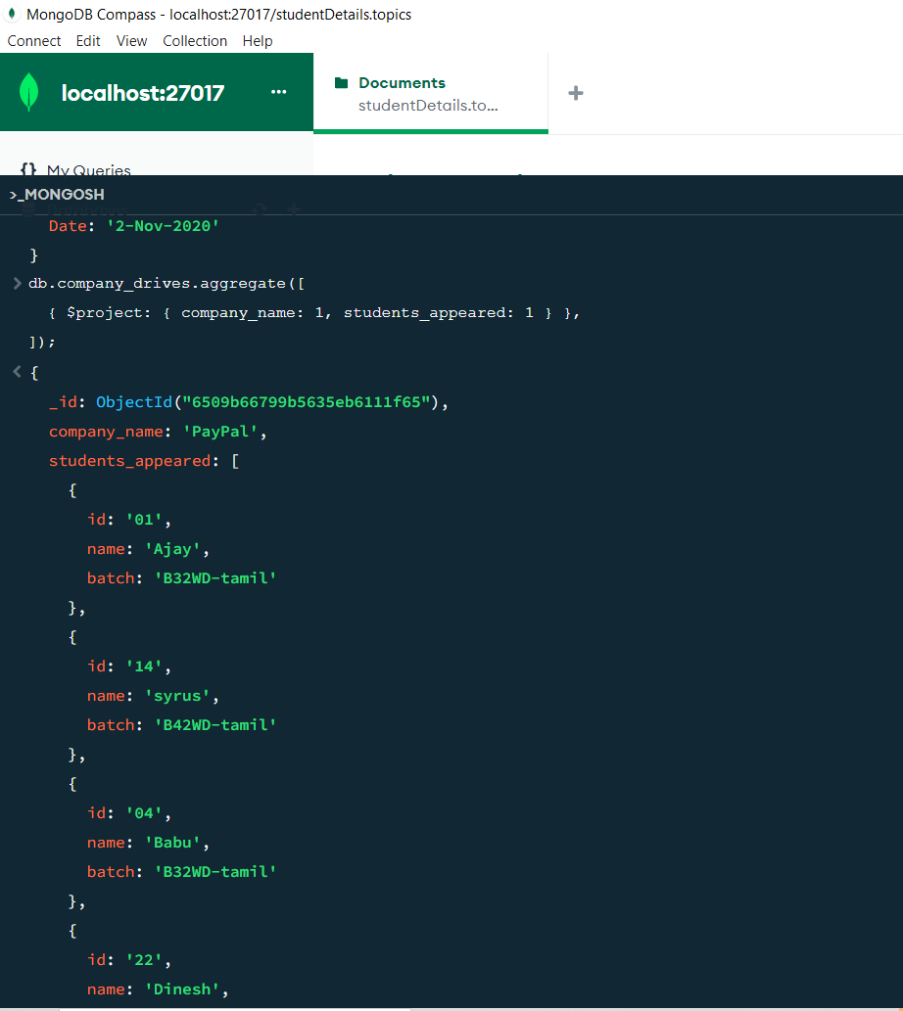

***4.Find the number of problems solved by the user in codekata.***

db.codekata.aggregate([{ $project: { id: 1, name: 1, codekata_solved: 1 } }]);

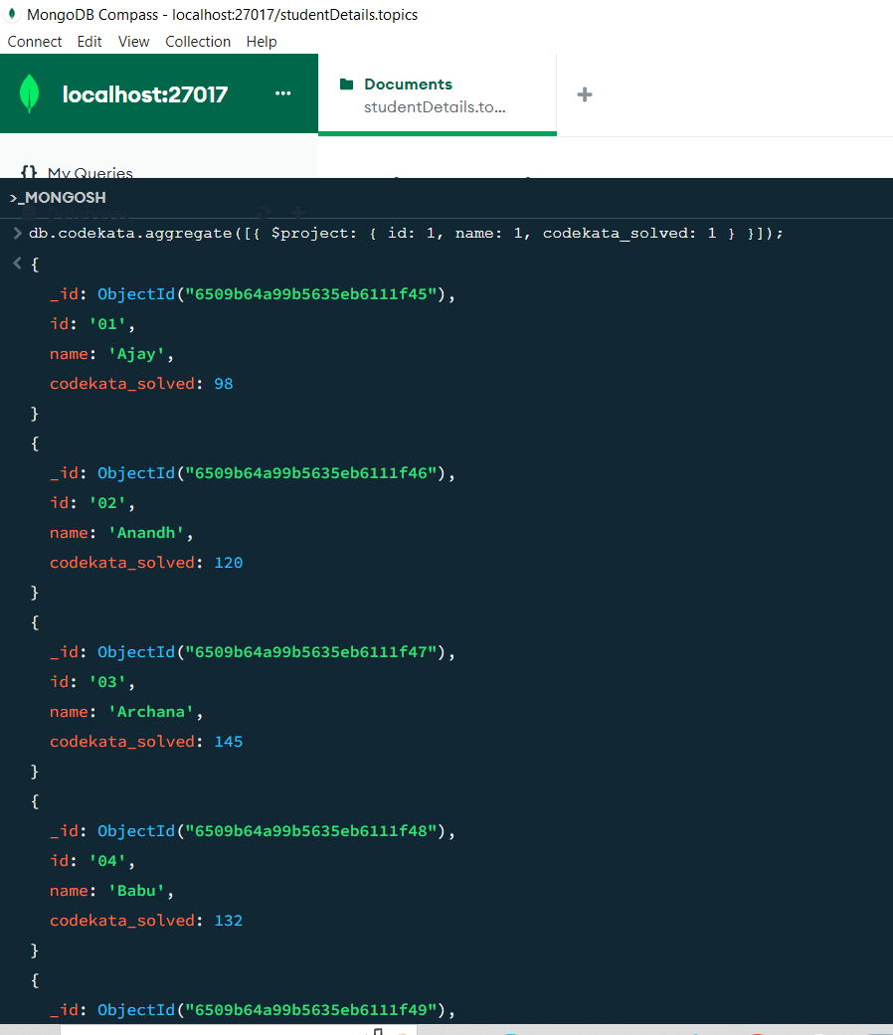

***5.Find all the mentors with who has the mentee's count more than 15***

db.mentors.aggregate([

{

$match: {

no_mentee: { $gt: 15 },

},

},

]);

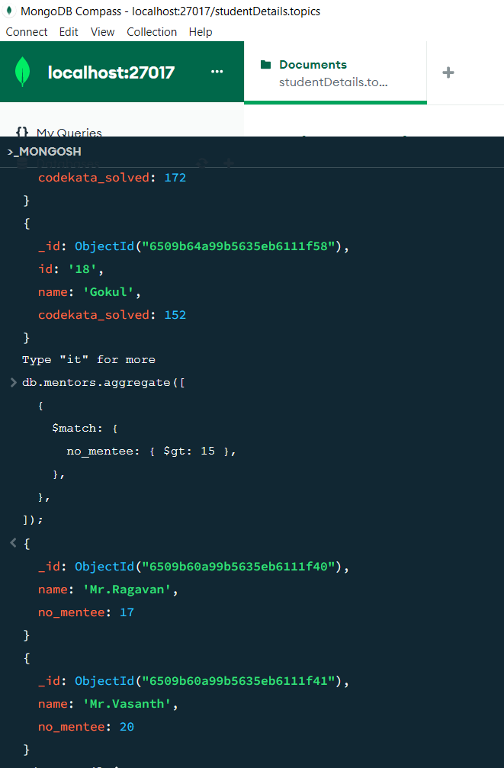

***6.Find the number of users who are absent and task is not submitted between 15 oct-2020 and 31-oct-2020***

db.attendance.aggregate([

{ $match: { date: { $gte: "15-oct-2020", $lte: "31-oct-2020" } } },

{ $project: { date: 1, number_of_absent: 1, task_not_submitted: 1 } },

]);

